Angular test

1. INIT ANGULAR PROJECT

a. Create new Angular Project.  
 b. You may use any Library to implementation that you are familiar with.

(PrimeNg/ Angular Material/ Bootstrap…).

c. You can send the code with Github / Rar/Zip file.

Your final score will be determined upon a successful implementation and following Angular best practices.

2. CREATE TABLE

a. Create Table with 3 columns (Id, Color Name, Color).

b. Color cells are specials and present the color background inside the cell

Initial data of the table:

**colors** = [ {**id**: 1, **name**: **'Red'**, **color**: **'red'** },  
 {**id**: 2, **name**: **'Blue'**, **color**: **'blue'** },  
 {**id**: 3, **name**: **'White'**, **color**: **'white'** },  
 {**id**: 4, **name**: **'Green'**, **color**: **'green'** },  
 {**id**: 5, **name**: **'Yellow'**, **color**: **'yellow'** }];

This is how the grid should look like after question 2.

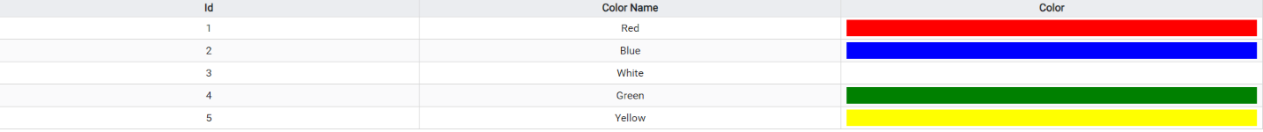

3. CREATE RANDOM DIALOG

a. Click on color cell will pop up dialog that Contain String

The Sting need to be:  
 “Change **<Selected Color Name>**To Random Color That Already Exist In This Table”

b. Add 2 Buttons Inside footer of the dialog

Cancel – close this dialog.

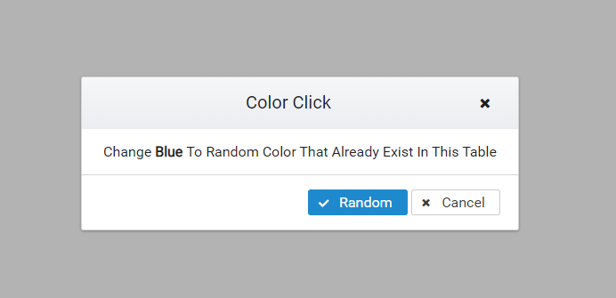Random – Pick random color from existing list and copy his values to the selected one.

4. CREATE NEW COLOR DIALOG

a. Add ‘New Color’ Button that open another dialog with:

Color Name - Then Name of the Color

Color – Style color (for example can be #FF0000 or red)

b. Add 2 buttons Inside footer of the dialog

Cancel – Close this dialog.

Submit – Add the color to the grid, so he can be optional color for the next Random.

c. the inputs need to be required and submit button need to be enable when the input are filled.

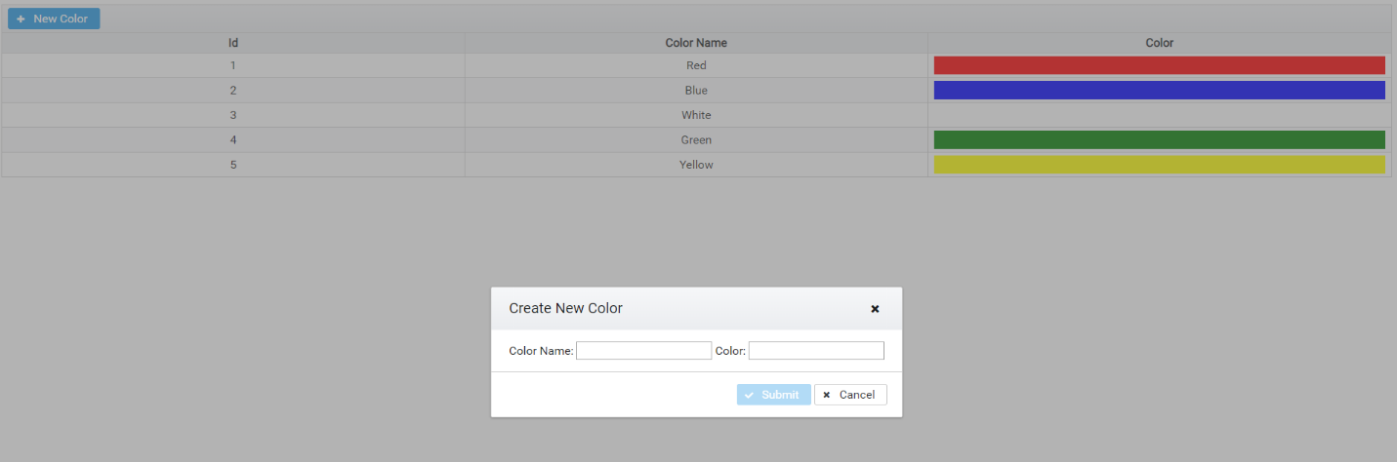** Add Validation If Needed

5. PRINT EVENTS

For New Color: “New Color <Name of Color>”

For Random: “Update <Id of selected> to < new random color>”

